2014
UCI RegCourse TestCase
Team Assignment
Team-D
Team-D
Kesha Smith
IC&SCI X460.42 – Java Programming I
November 30, y

Overview – Student Registration Program
Your team assignment is to write a console application used to register students for a course. The data for the registration system will be stored in one or more text files. You will follow the Systems Development Life Cycle (SDLC) to develop the application using a waterfall methodology. I will provide a requirements document, but your team will be responsible for several other deliverables during each lifecycle phase:

Phase | Deliverable
Requirements | Requirements Document
Analysis | Use Case Diagram, Activity Diagram
Design | Technical Design
Construction | Source Code, Version Control Sheet
Testing | Test Report
Implementation | Timely Submission to Assignments Folder

Please understand that the final grade on your team project is not based solely on the source code. You will be graded based on each deliverable noted above. In addition, your individual participation on the team project will be evaluated; subsequently, your grade may suffer if you do not actively contribute to your team assignment.

Assumptions

- The Use Case diagram can be created using any tool and will highlight all Use Cases for the system.
- You must submit all of your data files as a part of your assignment.
- Your source code must be submitted in a single zip file containing the group name.
- At a minimum, the version control sheet must include the name of the updated file, the date the change was made, the name of the person making the change, and a high-level description of the change.
- Have one person submit your final project to me.
- Your program will be designed using object oriented techniques.
Requirements

The student registration system will display the list of courses available for registration. The program should show current registration numbers and available seats for each course. After a student successfully registers, the registration information should be stored in a file.
The system should provide several features:
- The ability for students to view an alphabetical list of courses that includes the course identification number, course dates, name, brief summary, the enrollment limit, and the number of students already enrolled.
- The ability for students to register or un-register for a course.
- The ability for a student to see a list of classes for which he/she is currently registered.
There are several business rules:
- The system should not allow a student to register for a full course.
- The system should not allow one student to view the registration information for another student.
- The system should not allow a student to un-register from a course for which he/she is not registered.

Requirements

Our plan is to create two csv files.
One is for student accounts. First column is the account, and the second column is the password.
Another one is for courses. First column is the course name. Second column is the total available seats. Third column is the schedule. Following columns are the registered students.
The database class has below functions.
1. createStudentAccount
- This will add one more row in the student accounts file.
2. checkPassword
- This is for login. Check if provided account/pw match the record in student account file.
3. registerCourse
- This is only for logged in student. This will add one more student name or delete one name in the course row in the course file.
4. getAvailableCourses
- This checks the courses row to see which rows do not have the logged in student name, and return all such courses.
5. getRegisteredCourses
- Similar to 4. Return all courses with the logged in student name in the course row.
6. checkSchedule
- Get the schedule from course file.
This database class only needs two instance variables.
1. Studnet name
- In default, it is null. Once student log in, the name will be the student name.
2. Database location
- Location of the files
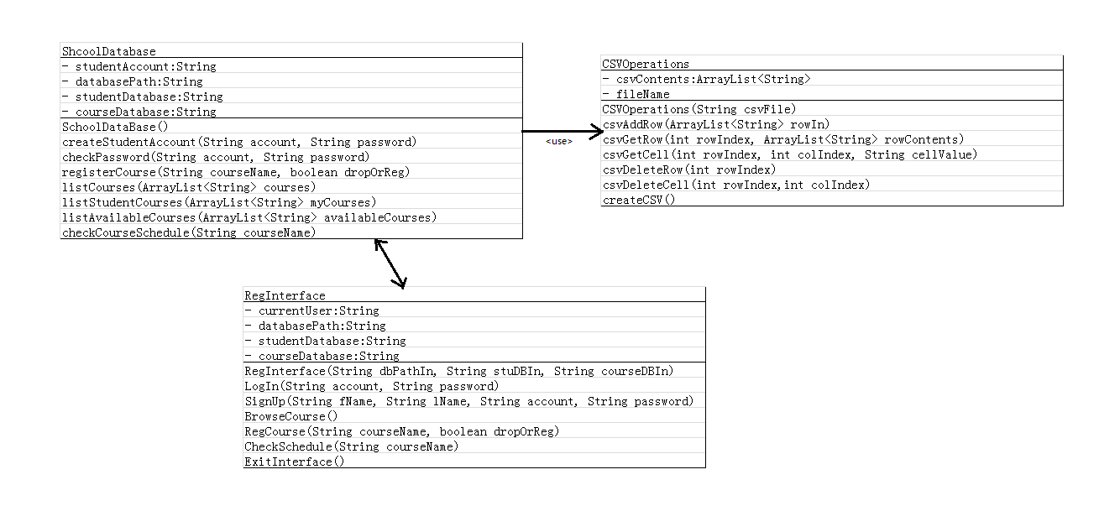
Requirements

Analysis
Use Case Diagram {Team-D}

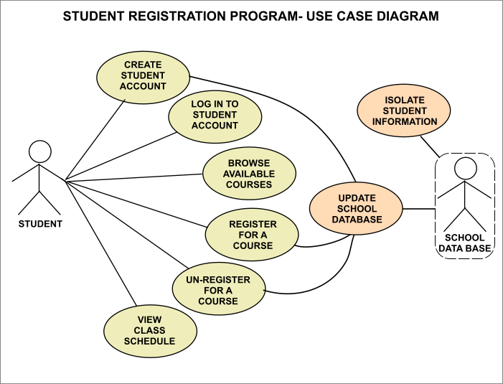

Analysis
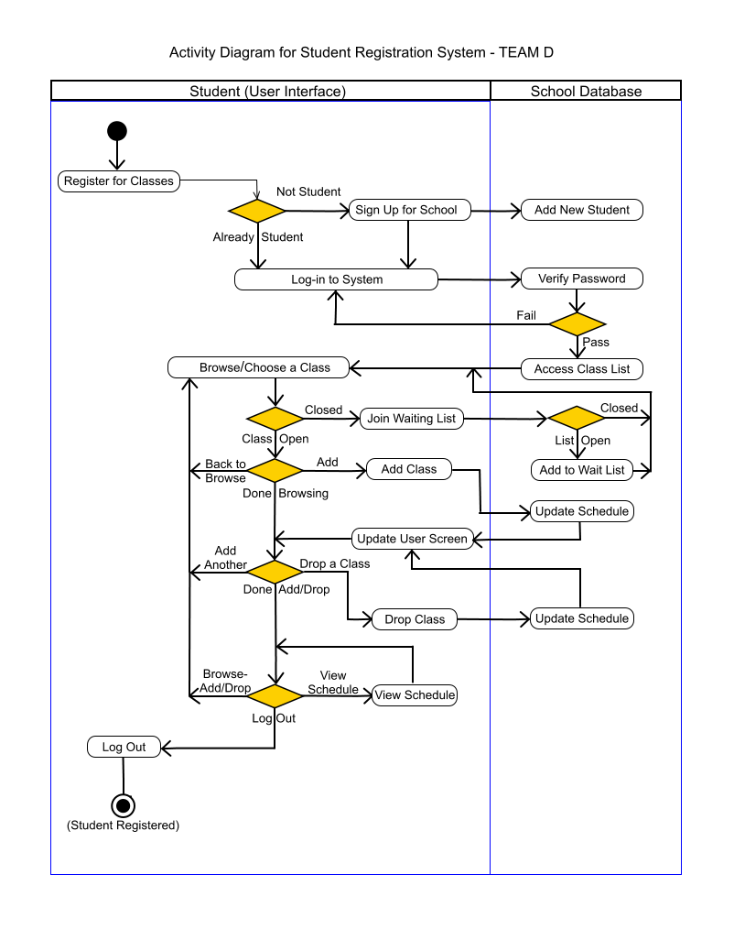
Activity Diagram

Design
Early functional UI screenshots
Technical Design

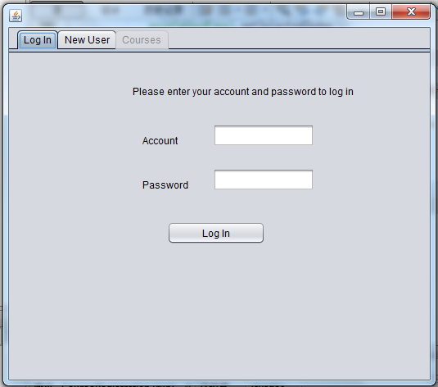
Design

Early functional UI screenshots
Technical Design

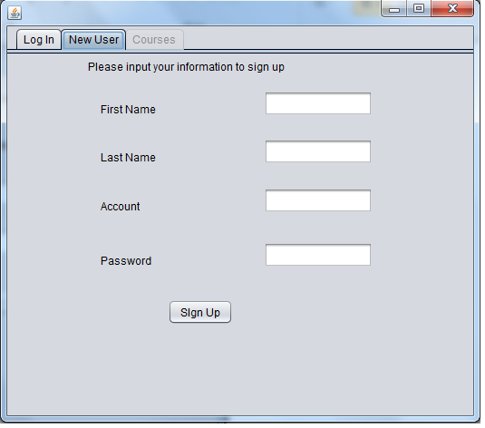

Design
Early functional UI screenshots
Technical Design

Matured UI screenshots

Design
Technical Design

Matured UI screenshots

Design
Technical Design

Matured UI screenshots

Design
Technical Design

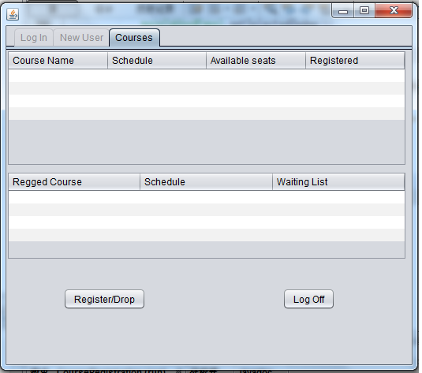
UCI_RegCourse_TestCase_OutLine

Construction
Source Code, Version Control Sheet

Date of Release | Revisions
 | Draft
7/3/14 | Added Final Releases and updated version notes.

Construction & Testing

 | Test Suite ID | TS001
 | Test Case ID | TC001
 | Test Case Summary | check csvOperation class functionality
 | Related Requirement | RR001
 | Prerequisites | JRE installed
 | Test Procedure | 1. Create database files. 2. check all function method in the class
 | Test Data | create studentdatabase and coursedatabase csv files for test
 | Expected Result | file operation should all pass
 | Actual Result | TBD
 | Status | TBD
 | Remarks | TBD
 | Created By | TAO CHENG
 | Date of Creation | 11/16/14
 | Executed By | TBD
 | Date of Execution | TBD
 | Test Environment | windows 7 or 8 or 8.1. java 8.
Construction & Testing
 | Test Suite ID | TS002
 | Test Case ID | TC002
 | Test Case Summary | check SchoolDatabase class functionality
 | Related Requirement | RR002
 | Prerequisites | JRE installed; CSVOperation class is tested ok.
 | Test Procedure | 1. create database files. 2. Link to CSVOperation class. 3. check all function method in the class
 | Test Data | create studentdatabase and coursedatabase csv files for test
 | Expected Result | file operation should all pass
 | Actual Result | TBD
 | Status | TBD
 | Remarks | TBD
 | Created By | TAO CHENG
 | Date of Creation | 11/16/14
 | Executed By | TBD
 | Date of Execution | TBD
 | Test Environment | windows 7 or 8 or 8.1. java 8.
 | Test Suite ID | TS003
 | Test Case ID | TC003
 | Test Case Summary | check RegInterface class functionality
 | Related Requirement | RR003
 | Prerequisites | JRE installed; CSVOperation class is tested ok; SchoolDatabase is tested ok.
 | Test Procedure | Check the menu switch described in menu mockup file
 | Test Data | create studentdatabase and coursedatabase csv files for test
 | Expected Result | file operation should all pass
 | Actual Result | TBD
 | Status | TBD
 | Remarks | TBD
 | Created By | TAO CHENG
 | Date of Creation | 11/16/14

Construction

WELCOME TO XYZ COLLEGE
======================

Please Sign up or Log in
------------------------
1. SIGN UP (press 1)
2. LOG-IN (press 2)

--------------------------------

OPTION 1:
____________________________
| ******************* |
| STUDENT REGISTRATION |
| FORM |
| ******************* |
| |
| FIRST NAME: __________ |
| LAST NAME: __________ |
| |
| CHOOSE AN ACCOUNT |
| PASSWORD: __________ |
|__________________________|

--------------------------------

OPTION 2:
____________________________
| ******************* |
| STUDENT LOG-IN PAGE |
| ******************* |
| |
| ACCOUNT #: __________ |
| PASSWORD: __________ |
| |
|__________________________|

--------------------------------

Please CHOOSE AN OPTION
------------------------
1. BROWSE CLASSES (press B)
2. ADD/DROP A CLASS (press A)
3. LIST CLASS SCHEDULE (press L)
4. EXIT BROWSING (press X)
--------------------------------

OPTION 1:
____________________________
| ******************* |
| BROWSE CLASS LIST |
| ******************* |
| |
| COURSE CLASS# |
| _____________________ |
| ALGEBRA I.......13333 |
| ALGEBRA II......23333 |
| CHOIR I.........12222 |
| CHOIR II........12222 |
| ENGLISH I.......15555 |
| ENGLISH II......25555 |
| JAVA I..........14444 |
| JAVA II.........24444 |
| SPANISH I.......11111 |
| SPANISH II......11111 |
| |
| NEXT PAGE--> (press N) |
| <--PREVIOUS (press P) |
| |
| ADD A CLASS (press A) |
| |
| BACK TO MENU (press M) |
|__________________________|

OPTION 2: (CLOSED)
____________________________
| ******************* |
| ADD/DROP A CLASS: |
| ******************* |
| |
| ENTER CLASS # 14444 |
| |
| 30 SEATS/30 SEATS |
| -OPEN- [CLOSED] |
| |
| ***CLASS IS CLOSED*** |
| |
| WAITING LIST: OPEN |
| (5/10 SEATS) |
| |
|JOIN WAITING LIST(Y/N)?: |
| |
| Y = JOIN LIST & CONFIRM |
| N = BACK TO MENU |
|__________________________|

OPTION 2: (OPEN)
____________________________
| ******************* |
| ADD A CLASS: |
| ******************* |
| |
| ENTER CLASS # 14444 |
| |
| |
| [OPEN] -CLOSED- |
| |
| ***CLASS IS OPEN*** |
| |
| |
| ADD THIS CLASS (Y/N)?: |
| |
| Y = ADD CLASS & CONFIRM |
| N = BACK TO MENU |
|__________________________|

Please CHOOSE AN OPTION
------------------------
1. BROWSE CLASSES (press B)
2. ADD A CLASS (press A)
3. DROP A CLASS (press D)
4. EXIT BROWSING (press X)

____________________________
| ******************* |
| DROP A CLASS: |
| ******************* |
| |
| ENTER CLASS # 14444 |
| |
| |
| ***WARNING*** |
|THIS WILL DELETE CLASS!!! |
| |
| DROP THIS CLASS (Y/N)?: |
| |
| Y = DROP CLASS |
| N = BACK TO MENU |
|__________________________|

Please CHOOSE AN OPTION
------------------------
1. BROWSE CLASSES (press B)
2. ADD A CLASS (press A)
3. DROP A CLASS (press D)
4. EXIT BROWSING (press X)

____________________________
| |
| VIEW STUDENT SCHEDULE |
| |
| COURSE CLASS# |
| _____________________ |
| SPANISH I.......11111 |
| CHOIR I.........12222 |
| ALGEBRA II......23333 |
| JAVA II.........24444 |
| ENGLISH I.......15555 |
| |
| |
| BACK TO MENU (press M) |
| |
|__________________________|

Please CHOOSE AN OPTION
------------------------
1. BROWSE CLASSES (press B)
2. ADD A CLASS (press A)
3. DROP A CLASS (press D)
4. EXIT BROWSING (press X)

____________________________
| ******************* |
| LOG OUT OF SYSTEM |
| ******************* |
| |
| ***WARNING*** |
| THIS WILL LOG YOU OUT!!! |
| |
|LOG OUT OF SYSTEM (Y/N)?: |
| |
| Y = LOG OUT OF SYSTEM |
| N = BACK TO MAIN

Implementation
Timely Submission to Assignments Folder

Some Testing Corrections (12-3-14 by TMV):
- Can we DROP classes by selecting the currently registered ("Regged") list in the BOTTOM window, instead of from the top? It is confusing.
- FYI... "Regged" is not a real word in English. Maybe "Current" or "Student" instead?
- Can we display the Name of the logged in student- maybe at the top near the Java Logo?
- The Waiting List should be in the TOP window. It means nothing to a student who is already registered.
- Top menu, should spell as "Registered" instead of "Registerred".
- When I manually change the number of seats to "0", I can still register for the class. I should not be able to register for a 0 seat class.
- When I drop the class that has 0 seats, it should change to 1 seat at the top.
- CSV files did not update for me. If I exit the program and run it again, I have to sign up all over again. I think it is because of where CSV is located.[ C:\Users\kieky\Documents\NetBeansProjects\CourseRegistration ] This is the Windows User area. This was not good for testing. Need to move your project outside the User/kieky path.
Again, great work, Tao. Thanks for your efforts!

-Tom

P.S. I am still working on getting JUnit Class Testing to work in NetBeans

Implementation
Timely Submission to Assignments Folder

Description:
1. Database files are in csv format. You can open them with text pad. They are just text files.
2. If you want to add more courses or change courses, you need to update the schooldatabase.csv. There is no other way can do this as we did not add "administrator" to this system.
3. New users need to sign up first. Upon sign up, the user account and password will be save into student.csv, and log into system with this account.
4. Returning users need to log in with their accounts/passwords. The tool will check password from the student.csv. If match, the tool will log the student in.
5. After log in, the course page will show up course information with two tables.
6. Top one is course table which will list all courses. Available seats means how many seats are left. If it is 0, that means you will go into waiting list if you still want to register this course.
7. Bottom table is the student course table. It will list all the courses student has registered, and let the student know if he/she is in waiting list or not.
8. If you want to drop/register one class, just select the course on the top table and click the drop/reg button. If you have already registered, you will drop the course. If you have not, you will register the course.
9. Once you click log off, you will go to first login page again.
10. I do not want to enable selection for the bottom table as I think it will lead to confusion if you select a different one in the top table. Then, I do not know if you want to drop or register as two selections may point to two different courses.
11. Do not edit the table in the tool. Do drop/reg from clicking button, do sign up from the sign up page. I do not see any reason you will need to edit the table in the tool as the table should be controlled by the database.

